**Press Release**

**Noventa Romania Celebrates 20 Years of Success**

Timişoara/Diepoldsau, September 2024

This year marks a significant milestone for **Noventa Romania S.R.L.** as the company celebrates its 20th anniversary. To honor this occasion, a special event was held at the Timişoara plant at the end of August, where employees and their families were invited to join the festivities. Representatives from Noventa Switzerland, including **Philippe Bürki** (CFO Noventa AG)**, Reinhard Maurer** (Board Member), and **Dieter Marxer** (Board Member), also attended the event.

Honoring Employee Dedication and Company Milestones

In his opening remarks, **Radu Cotuna**, Managing Director of Noventa Romania, reflected on the company’s remarkable journey since its founding. He highlighted the recent years of growth, symbolized by the completion of the plant's expansion, and expressed his gratitude to the owners of the Noventa Group for their unwavering support during this successful period. Most importantly, Cotuna extended his heartfelt thanks to the employees for their dedication and strong commitment to the company, emphasizing that many have been with Noventa Romania for a significant length of time. Special recognition was given to **Jebelean Vasile** and **Semeniuc Vasile,** who have been with the company since its inception 20 years ago.

**A Special Message from Radu Cotuna**

"*As we mark our 20th anniversary, I want to take a moment to recognize the hard work and dedication of our team. Reaching this milestone has been a collective effort, and I'm grateful to everyone who has contributed to our journey. We're proud of what we've accomplished and look forward to continuing to serve our customers and partners with the same commitment and integrity in the years to come."*

A Night of Celebration and Entertainment

The event also featured a speech by company founder Florentin Banu, who entertained the audience with humorous anecdotes from Noventa Romania's 20-year history. **Dieter Marxer** of Noventa Switzerland followed with his own remarks, thanking Banu for the trust he placed in the Noventa Group when he handed over Interpart Productions eight years ago.

The celebration took place in perfect summer weather, providing a relaxed atmosphere for guests. Children were delighted by various attractions, including a puppet show and a bouncy castle, while refreshments and food were abundantly available. The highlight of the evening was a live performance by the renowned Romanian singer and entertainer **Horia Brenciu** and his 10-piece band, creating unforgettable moments for all in attendance.

**_____________________________**

|  |  |
| --- | --- |
| Founded | 2004 as Interpart Productions S.R.L. by Florentin Banu |
| Acquired by Noventa Group | 2016 |
| Rebranded | 2019 as Noventa Romania S.R.L. |
| Employees | 295 |
| Annual Revenue | EUR 27 million (CHF 26 million) |
| Managing Director | Radu Cotuna |

**Fact Box:**

**For further information, please contact:**

|  |
| --- |
| Noventa AG  Martina Baldauf  Marketing Communications  [media.ch@noventa.com](mailto:media.ch@noventa.com)  T +41 71 737 95 00 |

**Keywords:**

**Noventa Romania S.R.L., Noventa AG, 20th Anniversary, Company Milestone, Radu Cotuna, Florentin Banu, Timişoara Plant, Noventa, Employee Recognition, Business Growth, Company Expansion, Horia Brenciu, Interpart Productions, Romania Business, Corporate Celebration, Employer Branding**

**Ein Bild, das Kleidung, Person, Mann, Menschen enthält.
**

Managing Director Radu Cotuna (right) presents a small token of appreciation to long-standing employee **Semeniuc Vasile.**

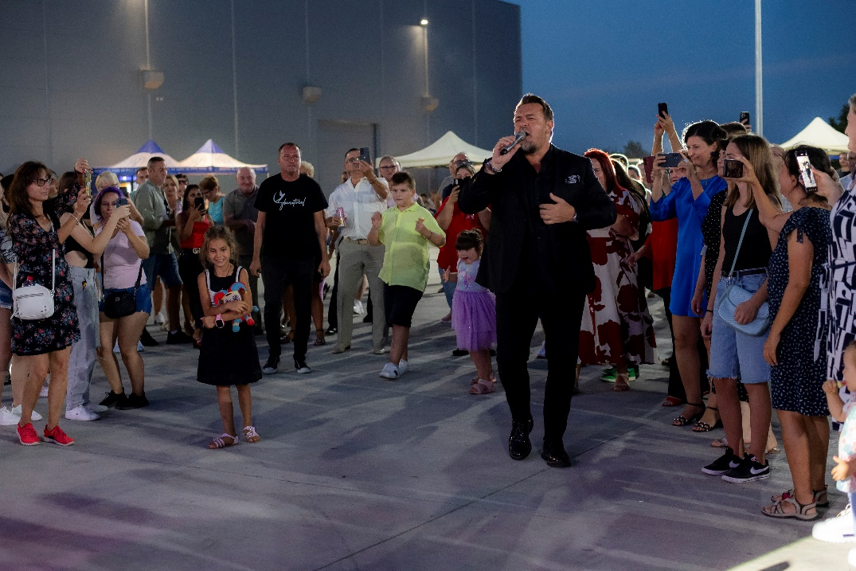

*Horia Brenciu surrounded by Noventa employees*.