Press Release
Diepoldsau/Widnau, August 2024
Peter Heule: Half a Century of Innovation and Commitment at Noventa: A Well-Deserved Thank You Upon Retirement
Noventa AG and its subsidiary, Noventa Tooling AG, proudly and gratefully celebrate the extraordinary 50th anniversary of Peter Heule. His dedication and innovative spirit have not only significantly shaped the company's development but also left an impact on the industry. As he steps into retirement, we bid farewell to a valued colleague and an innovative forward-thinker.
Half a Century at Noventa
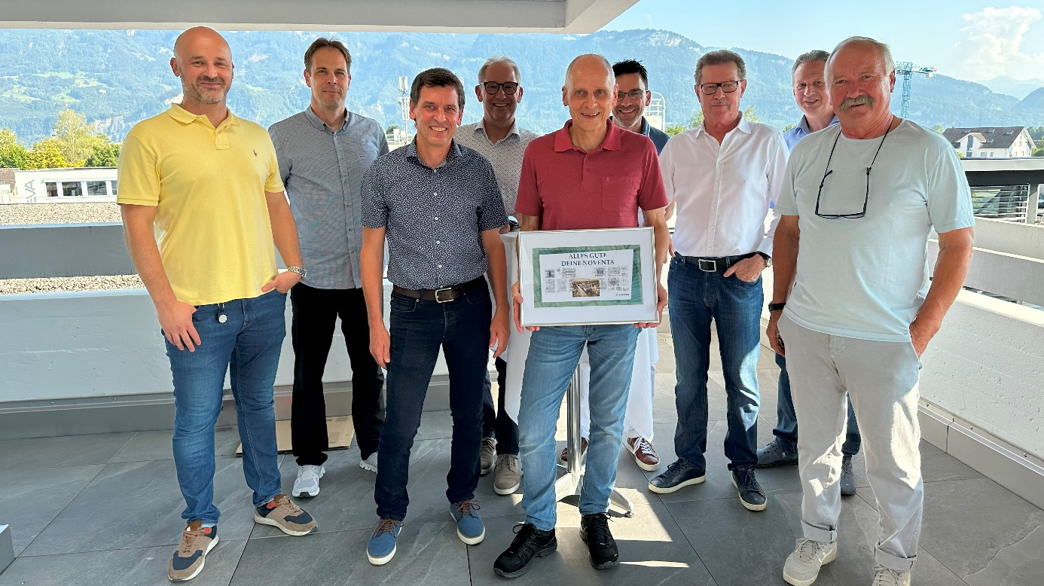
Peter Heule began his impressive career on April 16, 1974, at the former Baumann AG in Diepoldsau, which over time was renamed Noventa AG. Over five decades, he significantly contributed to the company’s development as a toolmaker and later as a tool designer. Today, he is a valuable member of Noventa Tooling AG, a subsidiary of Noventa AG.
Peter Heule (center) celebrates his 50th work anniversary at Noventa. Also in the picture (from left to right): Mirjad Keka (CBDO Noventa AG), Philippe Bürki (CFO Noventa AG), Jürg Eichmann (Management Noventa Tooling AG), Reinhard Maurer (Board of Directors Noventa AG), Dieter Marxer (Board of Directors Noventa AG), Alois Stähli (Board of Directors Noventa AG), Anis Rifai (CEO Noventa AG), and Charlie Huber (long-time companion).

A Life Dedicated to Toolmaking
Peter Heule discovered his passion for mechanical engineering early, inspired by his mother, who worked as a home-based employee at Baumann AG. "Even as a seasonal worker in production, I was fascinated by the machines in toolmaking," Peter recalls. This fascination became the driving force behind his impressive career, which began on a sunny spring day in April 1974.
Key Milestones and Innovations
Throughout his career, Peter Heule worked under five different leadership styles and was instrumental in significant innovations, including the introduction of 3D-CAD, supported by his mentor Alois Stähli. These and many other achievements form the foundation of the technological leadership that Noventa Tooling AG enjoys today.
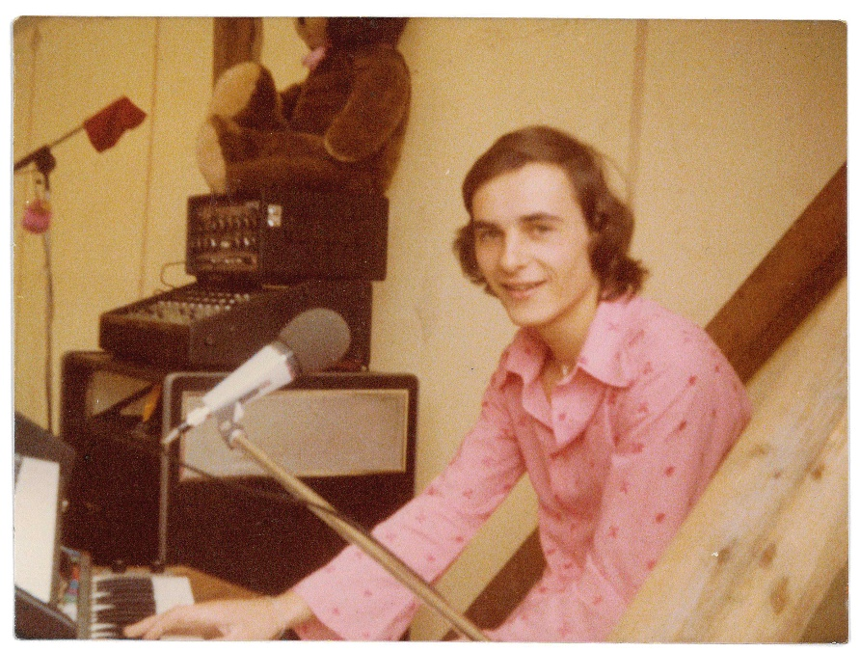
Personal Anecdotes and Lasting Memories
Peter has witnessed not only technological developments but also many personal milestones, such as his transformation into a coffee drinker after 22 years and the legendary Christmas parties, where he performed as a musician. His consistency is also evident in small things, such as using the same office chair for decades.
"Peter is not only an outstanding tool designer but also an inspiring role model for all our employees," says Jürg Eichmann, Managing Director of Noventa Tooling AG. "His tireless commitment and innovative spirit have left a lasting mark on our company."
An Example of Loyalty and Commitment
With his retirement, Peter plans to continue working part-time for Noventa Tooling AG and spend more time with his family, especially his grandchildren. His exceptional loyalty and dedication are shining examples of the values cherished and promoted at Noventa.
Thanks and Recognition
The board of directors and management of Noventa AG and Noventa Tooling AG would like to express their deepest gratitude and appreciation to Peter Heule for his valuable decades of service. His commitment, expertise, and leadership qualities have enriched and advanced the company in many ways. It is a privilege that Peter has decided to continue supporting us even after his official retirement. This commitment once again highlights his extraordinary character and deep connection with our company.

About Noventa Tooling AG
As a subsidiary of Noventa AG, Noventa Tooling AG, based in Widnau, is a leading manufacturer of 2-component and high-performance tools. With decades of experience and the use of cutting-edge technologies, the company sets standards in tool manufacturing. More than 20 dedicated employees in Widnau continuously optimize processes and improve molded parts to meet the high demands of the market. Absolute quality and on-time delivery are a given.
_____________________________
For further information, please contact:
Noventa AG
Martina Baldauf
Marketing Communications
media.ch@noventa.com
T +41 71 737 95 00

Keywords: Noventa Tooling AG, 50th work anniversary, toolmaking, Noventa AG
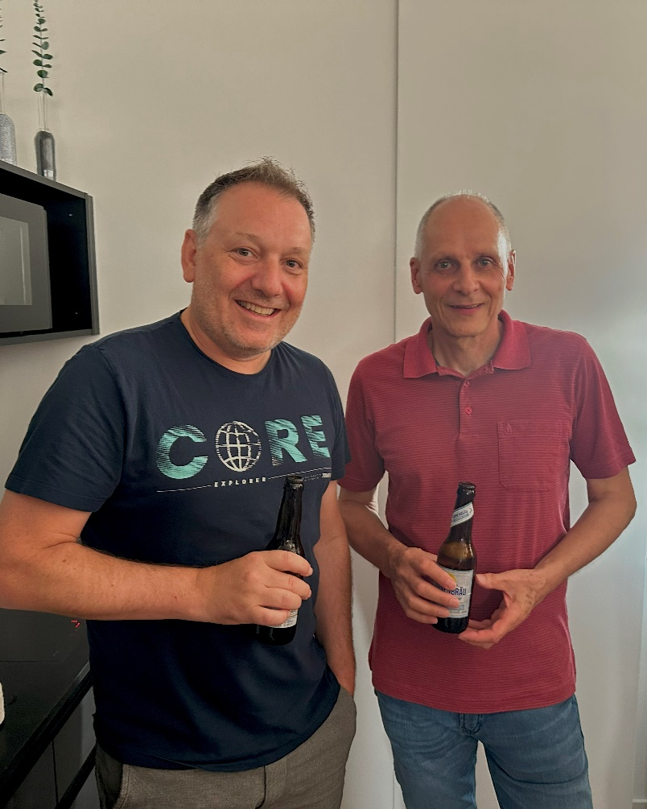
Rainer Widmer und Peter Heule.

